Working Principles of JNCDAS In Order to Create an Enabling Environment
Awareness
Enrichment of Learning
Building Synergies between stakeholder
Grievance Redress

Activities and Initiatives: Awareness about Rights and Capabilities of Divyang
- Celebration of the International Day for the Persons with Disability (IDPD) on December 3 every year
- Regularly organized G.K. Competition , Debate Competition and Essay competition for the divyang students
- Felicitation of achievers
- Celebration of White Cane Day and Braille Day
- Commemoration and Tribute to eminent Differently -abled persons

COMPUTER LAB AT CENTER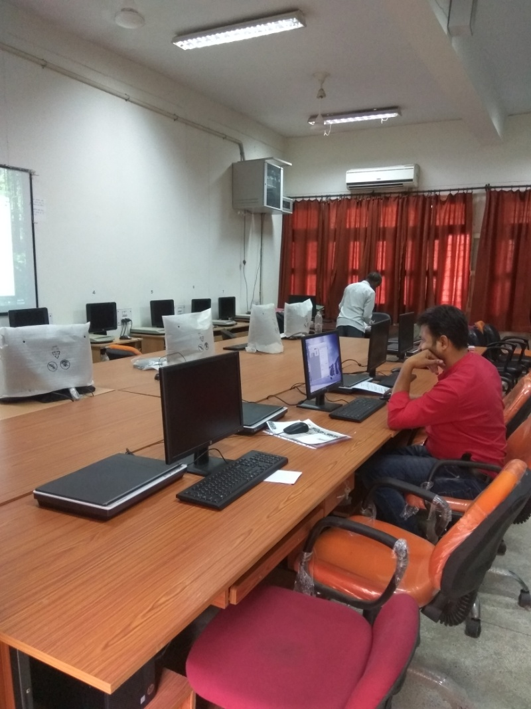

Activities and Initiatives of JNCDAS: Residential facilities
- Admission in the UP State Government Hostel for Visually Challenged has been a successful initiative
- State Government Hostel is specially designed for the differently- abled persons
- Residential and mess facility is available at nominal cost in the Hostel
- All rooms are single seated
- Each year more than 40 students get accommodation in State Government Hostel
Activities and Initiatives: Use of Technology for Access to Reading Material
- Lab at the Centre has 10 new computers with wifi and 5 scanners
- screen reading soft wares ( NVDA or Non Visual Desktop Access )
- E-books (digital E- learning material was acquired from other resource centers)
- There are 392 e- book in 12 different subjects
- Also, Braille books available at Central Library of the University

White Cane Day ( 2018): Inauguration of Newly Acquired ICT Infrastructure
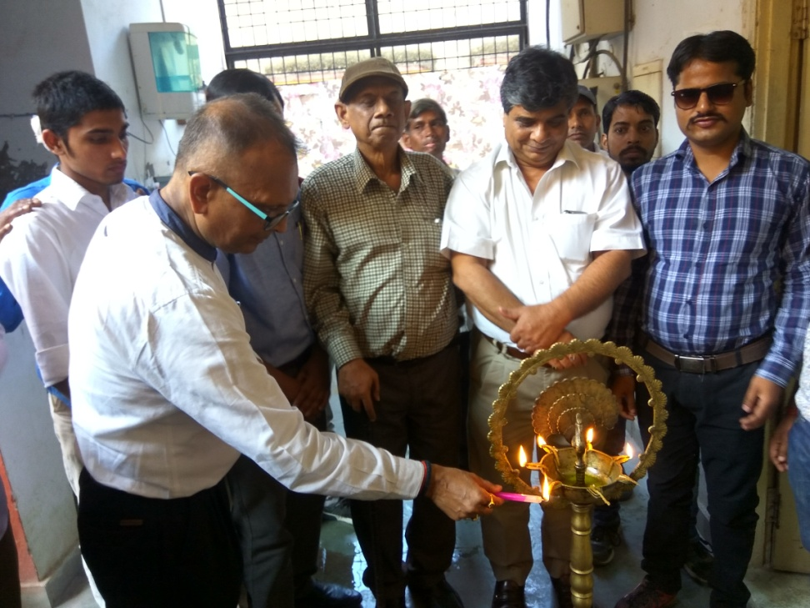

International Day For Persons with Disability Function, 2018
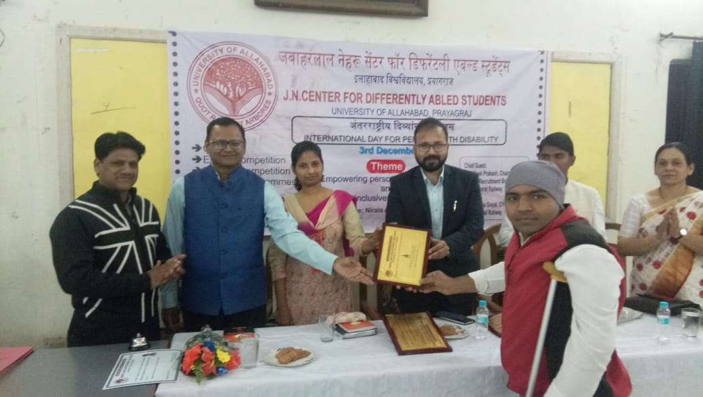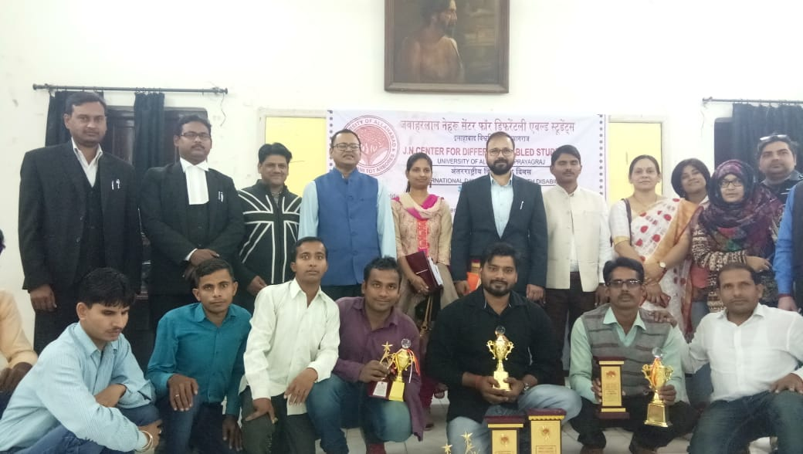

Media Reports
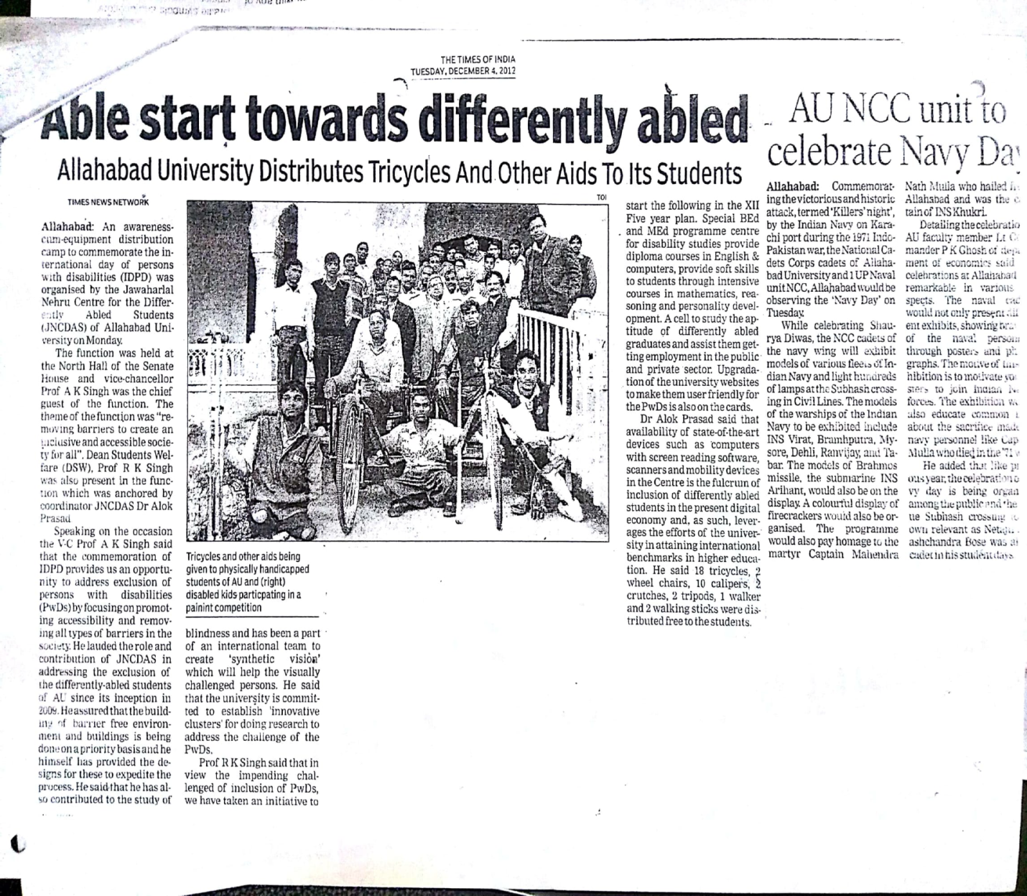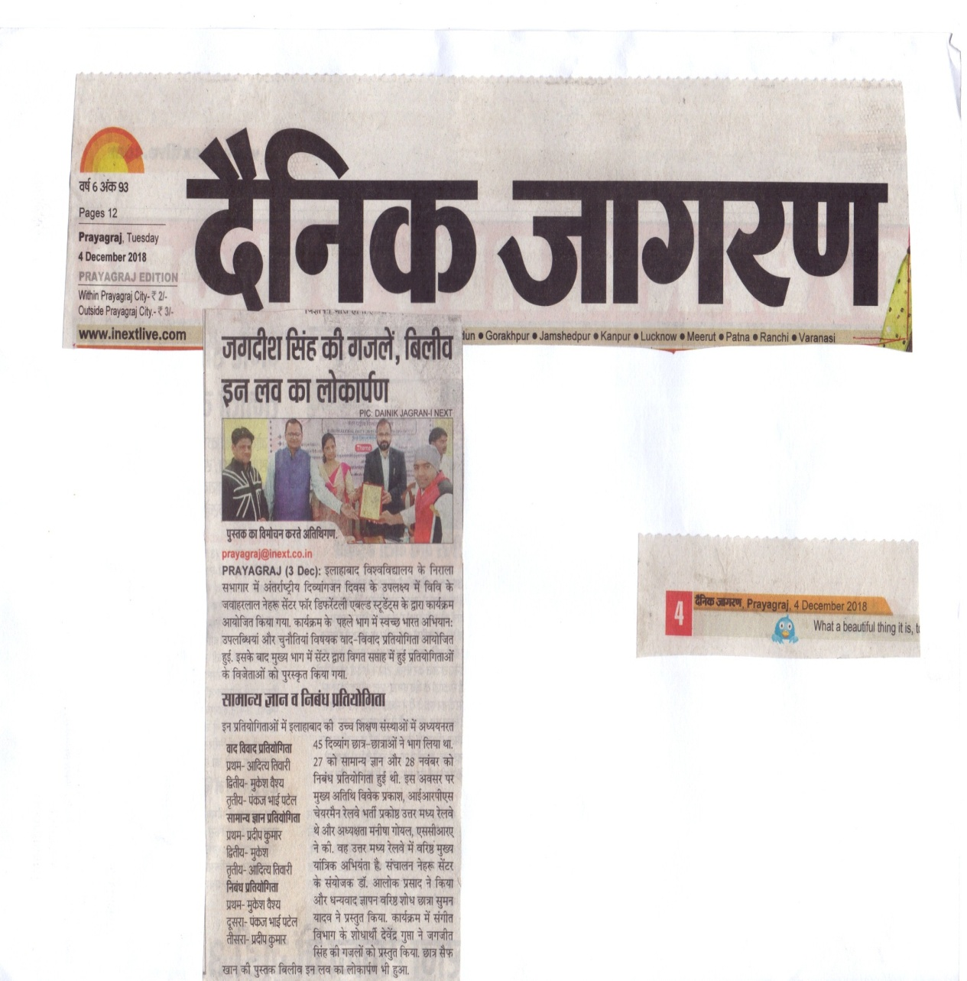
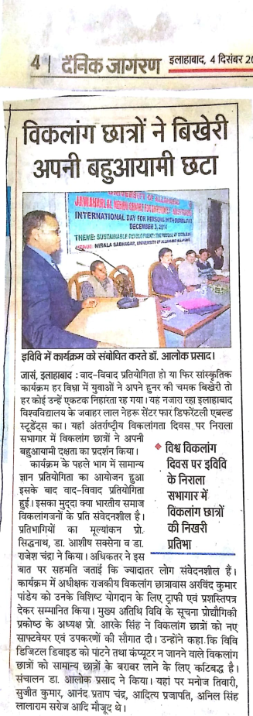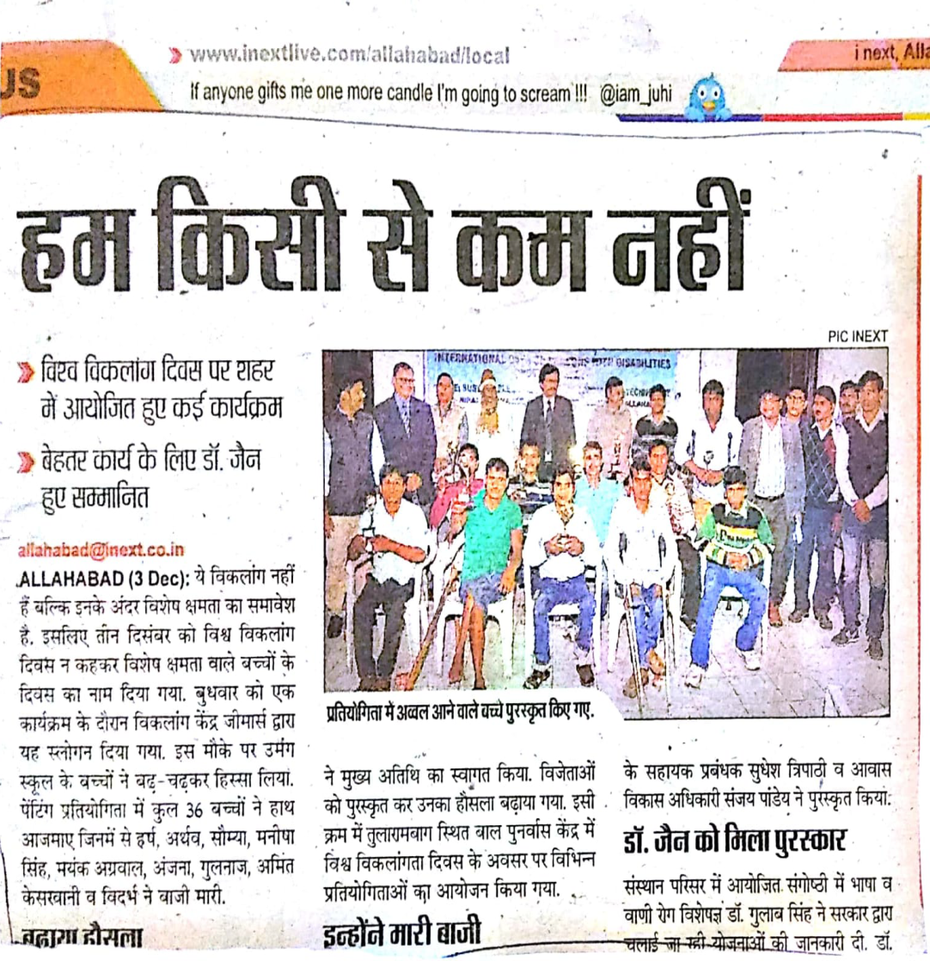
Felicitating Prof. Siddhnath (Head, Law Department) on Lifetime Achievement, 2017

